Valuing & Comparing Patterns of Payments
Richard P. Rumelt

The standard toolkit of every analyst includes computing present values. The purpose of this note is to focus attention on the three issues that create the greatest confusion and error in practice. They are (1) dealing with financing expenses, (2) dealing with capital investment, taxes, and depreciation, (3) dealing with terminal values, and (4) presenting managerially meaningful results.
This note does not address the issue of choosing an appropriate discount rate. That is a complex subject which will not be addressed here. In this note I assume that you have already determined the appropriate discount rate.

Smoothing and Time Shifting
Consider a set of monetary payments, each received at the end of each period, as shown in Exhibit 1. Payments are received at the end of each period. A payment of $100 will be received one year from “now,” a payment of $120 at the end of two years, and so on. Taking the discount rate k to be 10%, Excel’s NPV function reveals that the present-value of these payments is $297.81. What this means is that if we had $291.81 today, and if we could earn 10% per-annum (after any taxes!) on this amount, then we could reproduce these payments, running out of funds exactly at the end of year 5. Thus, this pattern of payments is equivalent, in terms of value, to a single payment today of $297.81
Exhibit 1
Period | 1 | 2 | 3 | 4 | 5
Payment | 100 | 120 | 50 | 30 | 80

That is the totally standard way of thinking about present-value and discounting. But, there is more. There are an infinite number of patterns of payments which are value-equivalent to this one and the analyst can construct them at will. Which one is constructed depends on the comparison being made.
For example, instead of a present value one can easily compute a future value. That is the financially equivalent amount were it received at the end of year 5. In this case, the future value is In the case of pension planning, this number might be more relevant than the present value.
One could just as easily compute the amount received at the end of period 2 that is financially equivalent to the original stream. That would be It is only a bit harder to compute the two equal amounts, received at the ends of periods 2 and 4, that are financially equivalent to the original pattern. They are each $197.30.
A useful transformation is to a level stream. To compute this one could use the finite annuity formula
as described in ASA Technical Note on Present Value Formulae, or simply invoke the Excel function PMT(k, 5, -297.81). Doing so produces the value $78.56. Receiving that amount each year is financially equivalent to receiving $298.81 now or to the original pattern. This sort of smoothing is especially useful in creating managerially meaningful numbers. For example, if these payments are for the maintenance of a machine, telling someone that maintenance expenses have a present value of $297.81 is not very enlightening. On the other hand, a maintenance charge of $78 per year is a better basis for comparison and judgment.
Importantly, note that this particular level stream of $78.56 per year lasts only five years. It is not hard to compute, instead, the equivalent 10-year level stream: PMT(.1,10,-297.81) = $48.47. The equivalent 20-year stream has annual payments of $34.98. As we make the stream longer and longer, it becomes an infinite annuity and the annual payment becomes .
The choice of the length of the equivalent annuity is important if the pattern of payments will be repeated in the future. For example, suppose that we are interested in the value of repeating the pattern of Exhibit 1 over and over again. Since this payment stream is equivalent to five annual level payments of $78.56, repeating the project over and over again is like an infinite stream of payments of $78.56 and we immediately know that its present value is $785.5.
Matching the payment stream length to the project length is also important in comparing streams of unequal length. For example, consider the two payment streams L and S, shown in Exhibit 2. Stream L is the same stream analyzed above and S is a shorter 3-year stream. If these payment streams were the whole story—if nothing else happened in the future—then it would be proper to compare their present values. Or to compare their annuity values for the same periods of time. That is, compare the equivalent 3-year annuities for both—the annuity values are proportional to the present values. The present value of L is larger and so are its equivalent level annuity payments for any length of time (78.6 > 56.3 and 94 > 67.4 and 119.8 > 85.9).
Exhibit 2—Comparing Streams of Different Length

Period | L | S |  | Stream Values | L | S
1 | 100 | 30 |  | Present value | $297.81 | $213.60
2 | 120 | 180 |  | 5-Year level payment equivalent | $78.56 | $56.35
3 | 50 | 50 |  | 4-year level payment equivalent | $93.95 | $67.38
4 | 30 |  |  | 3-year level payment equivalent | $119.75 | $85.89
5 | 80

But suppose that these patterns will be repeated in the future. That is, after 5 years, we can receive payment pattern L again, and then again after 5 more years, and so on. And the same with pattern S. Then the appropriate comparison is between the level payment annuities of corresponding pattern lengths. That is, the 5-year level payments for stream L should be compared to the 3-year level payments for stream S. Doing so flips the result, and stream L is more valuable (85.9 > 78.6). The intuition is straightforward. If pattern L is equivalent to receiving $78.6 per year for each of 5 years, then repeating it over and over again is equivalent to receiving $78.6 each year forever. And repeating pattern L over and over again is equivalent to receiving $85.9 each year forever.
This kind of reasoning often arises in capital projects. For example, a business my consider building a large facility which will last for 20 years. The present value of the expenditures and investments associated with the project has been computed to be $100 million (the discount rate is 10%). But what should be the terminal “cost?” That is, what costs should be expected to be incurred in years 21, 22 and so on? This is called the “terminal value” assumption. We know that the project has implications for future cash flows beyond the end date of the analysis, but what are they? Very often one sees analysts inserting a terminal “book value” of assets as a terminal value. Or the present value of perpetual payments equal to the last year’s income. Very often, a better assumption is that the project will simply repeat, over and over again. This rough assumption at least anticipates subsequent capital expenditures.
In the case at hand the NPV of the 20-year project is $100 million. The 20-year equivalent annuity amount for this is PMT(.1,20,-100) = $11.746 per year. Paying this much each year for 20-years is just a costly as doing the project. If we were to then do the project again, over and over again every 20 years, it would be equivalent to paying $11.746 per year forever. We could use that figure to compare it to a project of a different life and cost. Or, we can convert it into a “terminal cost”—the present value of paying $11.746 million each year forever is 11.746/.1 = $117.46 million.

Taxes, No-Profit Leases, and Depreciation
The average U.S. business pays federal and state income taxes at about a 38% marginal rate. Make sure you understand this simple equation (T is the tax rate):
{After-Tax Cash Flow Impact} = (1 – T) {Pre-Tax Income or Expense}.
This seems so simple it hardly merits attention. But the converse relationship is also true and can lead easily to confusion:
Suppose, for instance, that the analyst wants to compare leasing a facility for $18 million per year versus building it for $100 million (for the moment, assume that $100 million is the NPV of capital expenditures and that there are no expenses involved.) The facility will last about 20 years. As we computed in the example in the previous section, the 20-year finite annuity equivalent to the $100 million is $11.746 million per year. But it is not valid to compare the $18 million lease price to this $11.746 annuity. Rental and lease expenses are tax deductable and capital expenditures are not. Thus, the analyst should either compare the after-tax cash flows of (1-T)(18) to 11.746 or the pre-tax income/expense numbers of 18 and 11.746/(1-T). Both comparison are valid, they only differ by a scale factor. In both cases, the lease is cheaper. But, the pre-tax approach is the better way to do it.
In computing values we tend to use post-tax cash flows. But, in presenting expenses and income figures to managers, the analyst should seek to use numbers that are familiar ratios or prices. And, prices are pre-tax numbers. If you tell someone that an employee costs $18/hour in post-tax cash-flow terms, the hearer has to mentally gross that number up to make sense of it. Or, if someone computes the present cost of an employee who is expected to stay for 6 more years, the number makes sense to no one. Convert it to a level hourly wage and it does. My simple rule of thumb is this: when presenting one-time lumps of value and cost, use true cash flow (after any taxes). When presenting annual or monthly flows of income, expense, or cost, use pre-tax equivalents.
In the building versus lease problem, one could, therefore, compare the $100 million cost of the building to the present value of the after-tax lease cost over 20-years. It is $95 million. That is a comparison that some managers will immediately comprehend.
On the other hand, some managers will be much more comfortable thinking about space charges as annual, or even monthly, prices. So, it could also make sense to anchor on the pre-tax lease charge, perhaps converting both to monthly charges per square-foot.
I call converting a pattern of capital and expense flows into a pre-tax equivalent annuity creating a no-profit lease. There are three steps:
- Compute the present-value of normal expenses and any income associated with the project. Call it PVExp.
- Compute the present-value of the after-tax cash flows associated with capital expenditures and the sale of capital assets over the life of the project. Capital flows are naturally after-tax so the complexity here is handling their tax impacts. Call it PVCap.
- Combine them into a pre-tax level annuity over a period equal to the life of the project. Call it NPL (for no-profit lease) and compute it as
NPL = PMT(k, Life, (1-T)PVCExp + PVCap) / (1-T).
This number is the lease “price” we would have to charge someone else to break-even on making this investment, paying these expenses, and receiving back NPL each year from the lessee. By break-even, I mean that the rate of return on the deal is exactly k. To get this price, we have to gross-up the annual payment to a pre-tax number because we would pay taxes on NPL—it is income. Equivalently, it may be more intuitive to write:
(1-T)NPL = PMT(k, Life, (1-T)PVCExp + PVCap).
so that each term is an after-tax cash flow impact.
The no-profit lease number, NPL, is an annual “expense” that can be directly compared with other annual (pre-tax) prices, incomes and expenses.

Depreciation
Depreciation is a fictitious non-cash charge that is placed upon a company's books. The intent, many long years ago, was prevent firms from declaring dividends in excess of their need to replace capital. Today, that reason is obsolete as firms regularly pay out large amounts in excess of earnings by doing stock repurchases.
Depreciation's impact on cash is through the reduction in tax payments, or "tax shield," it provides. If you have $100 in depreciation, the fictitious expense reduces your taxes by 100T, or about $38 for most U.S. corporations. The complexity with depreciation is two-fold: it comes in "book" form and tax form and it is spread over time. Note that if depreciation were instant, capital expenditures would, essentially, be expenses. Buying a $100 million warehouse and depreciating it all in one year would have the same cash flow impact as $100 million in raw material or labor expense. Because depreciation is spread over time, its value is reduced and capital expenditures are "more expensive" than expenses of the same nominal amount.
The IRS lets companies depreciate property using the straight-line method or accelerated methods. Under the straight-line method, the asset is assigned a useful life and only the difference between cost and expected salvage value is depreciated. That is, annual depreciation is computed as . By contrast, accelerated depreciation is taken on the entire cost of the asset, ignoring any salvage value. Furthermore, accelerated depreciation charges are front-loaded, being larger in early periods. Since depreciation is a fictitious expense that acts to reduce tax payments, accelerated methods are generally preferred—the absolute amount of depreciation is larger and the present-value of front-loaded tax savings is greater.
Exhibit 3—Percentage of Capital Amount Depreciated Each Year (5 year life)
Year | Pure straight line | Pure double decline | MACRS straight line half-year conv. | MACRS accel. half-year conv. | MACRS accel. start in Q1 | MACRS accel. start in Q4
1 | 20.0 | 40.0 | 10.0 | 20.0 | 35.0 | 5.0
2 | 20.0 | 24.0 | 20.0 | 32.0 | 26.0 | 38.0
3 | 20.0 | 14.4 | 20.0 | 19.2 | 15.6 | 22.8
4 | 20.0 | 10.8 | 20.0 | 11.5 | 11.0 | 13.7
5 | 20.0 | 10.8 | 20.0 | 11.5 | 11.0 | 10.9
6 | - | - | 10.0 | 5.8 | 1.4 | 9.6
NPV @ 10% | 75.8 | 81.1 | 72.4 | 77.3 | 80.2 | 74.6

Accelerated depreciation rules and tables are available in IRS Publication 946. The overall idea is to encourage investment by shifting the tax deductions into earlier years. More detail on this appears in the Appendix to this note. The Appendix also describes the Excel user-functions MACRS and MACRS_PV which are available in the ASA add-in.
Exhibit 3 shows the percentage of the original capital amount invested that is depreciated in each year following under different rules. The pure straight-line and pure double-declining balance are only theoretical approximations. Real depreciation is constrained to begin in the middle of the year or quarter in which the investment was made. Thus, MACRS straight line depreciation of a 5-year property is one-half that of theoretical straight-line in the first year. And, it extends into the sixth year. In accelerated MACRS, look at the difference between starting in the middle of the first and last quarters.
Exhibit 4—Client Analysis
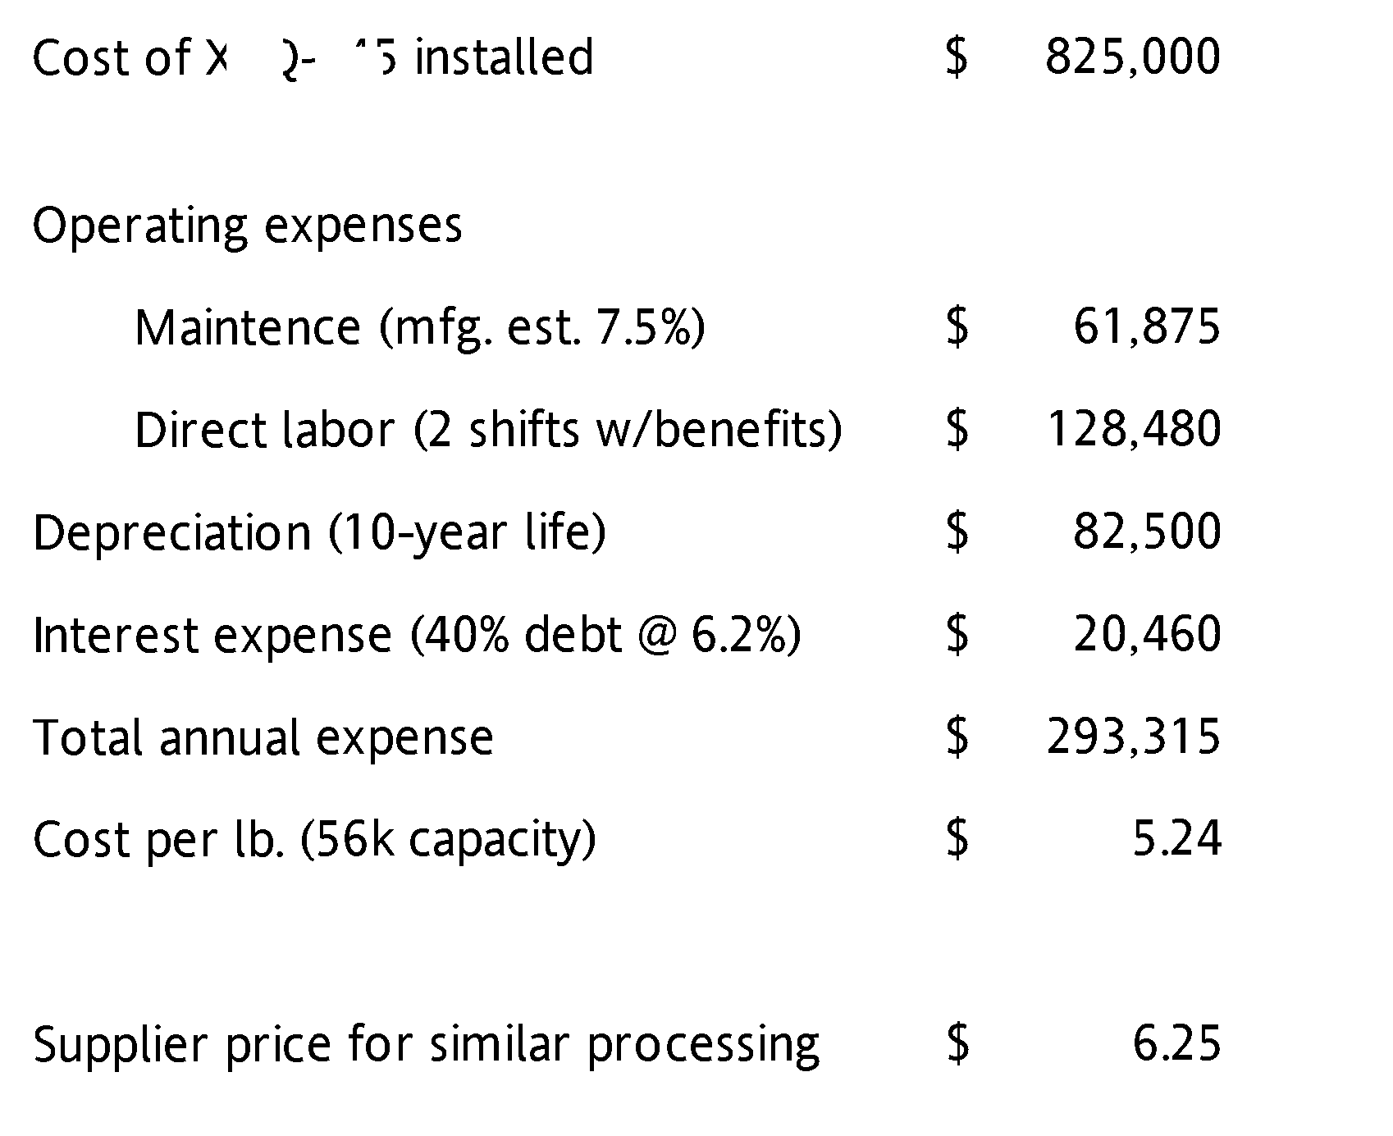
The last line of the table shows the present values of each stream. As you can see, the differences are not round-off error.
Getting depreciation and capital costs right matters. Exhibit 3 shows an analysis done by a client. In this case, the comparison being attempted was between buying and operating a materials-processing machine versus paying a supplier for similar processing. The client's financial office estimated a unit cost of $5.24 per lb. This cost had four components: maintenance expense, labor expense, interest expense and depreciation expense, with the latter computed on a straight-line basis over a 10-year usable life.
This sort of simple analysis, done thousands of time each day, is wrong. By neglecting the time value of money, the annual depreciation charge understates the "cost" of the machine. The machine must be paid for now, not over time. And, the interest expense understates the true cost of capital.
Here is how to fix the analysis. First, take out the interest expense. Yes, it is real cash, but we push the expense of both debt and equity into the cost of capital figure. Putting it here will double count the cost of debt.
Working in thousands, the company's capital expenditure of $825 is not a tax-deductable expense, but the fictitious depreciation charges are. Staying with the pure straight-line assumption, each $82.5 annual charge cuts the company's tax payment (0.38)(82.5) = $31.35. The company used a cost of capital of 10%, so the present value of those annual tax savings—the tax shield—is PV(0.1, 10, -31.35) = $192.6. This savings can be deducted from the original price of the machine to arrive at a net capital cost of $825 - 192.6 = $632.4.
At this point some analysts would take the present value of the expenses and the present value of paying the supplier instead and compare these present values. This will produce a correct numbers, and order the alternatives correctly, but it is not very helpful to management. The work already done suggests they are comfortable with annual figures and especially with cost per lb.
Take the $632.4 net capital cost and convert it into a no-profit lease. That will be
NPL = PMT( 0.1, 10, -632.4)/(1-tax) = $166.
This is how much the company would have to charge another for the machine to just break even on their cost of capital. It is almost twice as large as the depreciation charge they had been using. It is the annual "cost" of the machine.
Exhibit 5—Revisions to Client's Calculations
Item |  | Row Label | Excel Formula | Amount
Machine Purchase |  | price |  | 825,000
 | PV of pure STL depreciation | Pvdep | = -PV(kk,life,price/life) | 506,927
 | PV of tax shield at 38% | Pvdepts | = pvdep*tax | 192,632
 | Total PV of capital cost (price-shield) | Pvcapcost | =price - pvdepts | 632,368
Equivalent NPL |  | Npl | =pmt(kk, life, -pvcapcost)/(1-tax) | 165,992
 | Maintenance | Maint |  | 190,355
 | Labor | Labor |  | 128,480
Total annual expense |  | Totannexp | =npl + maint + labor | 484,827
Cost per lb. |  |  | =totannexp/56000 | 8.66

These calculations are shown in Exhibit 5. As you can see, the proper comparison is between $8.60 per lb. for the machine versus $6.25 for the supplier to do the same job. The company's analysis pointed to the wrong choice.
Further adjustments can be made to this analysis. The depreciation can be calculated on a real-world MACRS basis. A gain or sale, or salvage value, at the end of the machine's life can be introduced. These changes will not much alter the outcome—the big deal is the time value of money.
The error in using simple depreciation charges to as a "cost" of capital increases with the life of the capital because the impact of discounting also increases. Exhibit 5 displays a graph showing this effect.
Exhibit 6—Ratio of NPL lease equivalent of capital investment to naive annual depreciation charge for various capital durations (k = 10 %, T = 38%)
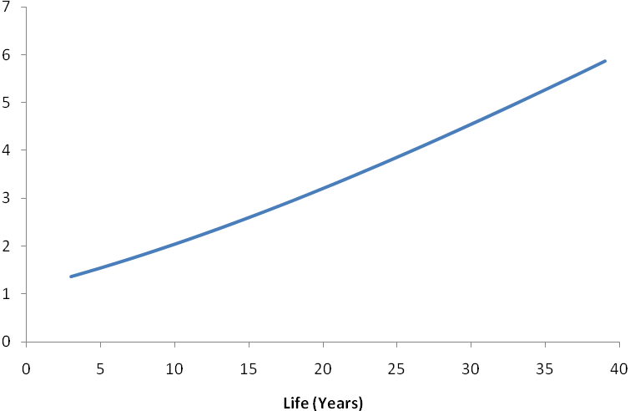

Appendix

Accelerated depreciation rules and tables are available in IRS Publication 946. The overall idea is that property is placed in a “property class” which determines the depreciation life. The table below provides a quick overview. (The rules for farm equipment, rental property, and Indian property are more complex.) As can be seen, most business equipment falls in the 5-year or 7-year property classes.

Exhibit 7—MACRS Class Lives (summary)
Property Class | Property Examples (non-farm) | Acceleration Factor
3-Year | Race horses, tractors for road use | 2
5-Year | Motor vehicles, computers, office equipment, R&D equipment, solar and wind energy equipment, commercial aircraft | 2
7-Year | Office furniture, racetracks, property not elsewhere classified | 2
10-Year | Water transport equipment, smart electrical grids | 2
15-Year | Restaurants, gas stations, utility distribution systems, landscaping | 1.5
20-Year | Utility grading | 1.5
25-Year | Water treatment and distribution | 1.5
Under the MACRS acceleration system, if an asset with cost C is placed into service, the accelerated depreciation during its first full year of service is where F is the acceleration factor (1.5 or 2) and L is the property-class recovery period (3, 5, 7, 10, 15, 20, or 25). The remaining balance at the end of the first full year will be . Thus, the second full year’s depreciation will be . The remaining balance after N full years of accelerated depreciation would be .
Notice that this balance never falls to zero no matter how large N becomes. To overcome this difficulty, the rules have one switch to the straight-line method when it yields a larger depreciation charge.
A further complexity is that the IRS rules do not start depreciation at the instant an asset is placed into service. Rather, depreciation begins in the middle of the year it is put in service, or the middle of the quarter, or the middle of the month. (The mid-month convention is restricted to real property.)
These complexities are all handled by Excel user-function macrs. This function returns the MACRS rule depreciation during a given year of an asset having a cost basis of 1. This function faithfully reproduces the MACRS tables in IRS Publication 946. It and its associated functions are described below.

macrs( life, year, [conv], [startperiod], [forcefactor])
Excel user-defined function macrs function takes the following arguments (square brackets around optional arguments):
life = the depreciable life of the asset in years
year = the year (1, 2, . . . )
conv = optional integer set to 1 for half-year convention, 4 for mid-quarter convention, and 12 for mid-month convention. If omitted, 1 is assumed. If set to 0, IRS rules about delaying the start of depreciation are ignored.
startperiod = optional integer indication which period the asset was placed into service. Set to 1 for first-year or first quarter or first month. Set to 2 for second quarter, or second month, and so on. If omitted, 1 is assumed.
forcefactor = optional number which defines the decline rate. The decline rate is normally set to 2 for properties with live of 10 years or less, 1.5 for properties with lives between 11 and 20 years, and 1 for properties with lives longer than 20 years. Note that setting forcefactor = 1 creates straight line depreciation.
Examples:
MACRS (7, 3) | Depreciation in year 3 for a 7 year property. Default half-year convention.
MACRS(7, 3, , , 1) | Depreciation in year 3 for a 7 year property. Default half-year convention. No acceleration (straight line)
MACRS(5, 4, 4, 1) | Depreciation in year 4 for a 5-year property, 4-quarters convention with start in the middle of the 4th quarter.
MACRS(10, 5, 0, , 1) | Depreciation in year 5 for a 10-year property, no delay and pure straight line. (Will return 1/10).

macrs_accum( life, thruyear, [conv], [startperiod], [forcefactor])
Excel user-function macrs_accum uses macrs to return the accumulated depreciation through the end of the given year. The arguments are
thruyear = the year through which depreciation should be accumulated
life, conv, startperiod, and forcefactor are as in macrs.
macrs_pv(rate, life, [thruyear], [conv], [startperiod], [forcefactor])
Excel user-function macrs_pv uses macrs to return the present value of the depreciation stream associated with an asset with a cost basis of 1. The argument list is:

rate = the discount rate expressed as a fraction
thruyear = present value taken on depreciation through the end of this year. If omitted, all non-zero depreciation is included. Note that under MACRS, some depreciation spills into the year = life + 1.
life, conv, startperiod, and forcefactor are as in macrs.

macrs_npl(rate, tax, life, salvage, endyear, [conv], [startperiod], [forcefactor])
Excel function macrs_npl returns the no-profit annual lease payment for a $1 investment. The arguments are:
rate = the discount rate expressed as a fraction
tax = the tax rate expressed as a fraction
salvage = the sale price of the asset at the end of endyear expressed as a fraction of the initial price.
endyear = the year in which the project terminates and the remaining assets are sold for salvage*price. endyear may be shorter or larger than life.
conv, startperiod, and forcefactor are as in macrs.

A Simple Example
A company can invest in either of two different machines labeled A and B. Machine A qualifies as a 5-year MACRS asset whereas machine B is a 7-year asset. The cost of capital is 10% and the tax rate is 38%. Their machines’ costs and salvage values are shown in Exhibit 7 (operating expenses are identical and can, therefore, be ignored in the comparison):
Exhibit 8 shows the analysis of these investments. The macrs_pv function is used to compute the present value of the depreciation stream. Multiplying by the tax rate gives the present value of the depreciation tax shield (the reduction in taxes). The MACRS rules leave out salvage values, so these rules leave a zero balance on the books at the end of its depreciation life. If the asset is then sold for a larger amount, there is a taxable gain on the sale (corporations do not get special capital gains treatments). The net (after-tax) cash cost associated with each machine is the initial outlay less the value of the depreciation tax shield less the after-tax gain on sale.
Exhibit 8
Machine | A | B
Cost | 1000 | 1200
Life in years | 5 | 7
Salvage Value | 100 | 0

As can be seen, the NPV of the after-tax cash costs for these machines are $668 and $847 respectively. However, these machines have different lifetimes. Consequently, the issue of their replacement must be considered—the less expensive machine will have to be replaced sooner. Lacking any additional data about future machine prices and lifetimes, the simplest approach to dealing with differing lifetimes is to convert each NPV into a level payment stream over the lifetime of the machine. That is, into a level annual lease rate. Excel function PMT does this and the last line of the analysis shows that machine B is less expensive.

Exhibit 9—NPL Calculations
 |  | Row label | A | B
Purchase price |  | price | 1,000.0 | 1,200.0
Lifetime |  | nyears | 5 | 7
Salvage Value |  | Salvage | 100 | 0
PV of depreciation tax shield | =tax*price*macrs_pv(coc,nyears) | pvdepts | 293.8 | 329.0
Gain on sale (after tax) | =(1-tax)*salvage | atgos | 62.0 | -
PV of gain on sale | =atgos/(1+coc)^nyears | pvatgos | 38.5 | -
Total PV of capital costs | =price-pvdepts-pvatgos | pvcapcost | 667.7 | 871.0
Equivalent annual cash flow | =pmt(coc,nyears,-pvcapcost)/(1-tax) | nplcapcost | 284.1 | 288.6
The above calculations have glossed over a small wrinkle. The gain on sale at the end of year 5 has not been adjusted for the remaining book value. MACRS depreciation delays the start and therefore extends beyond the nominal life.

U.S. federal marginal corporate income tax rates start at 15%, rise to 39% for corporate incomes between $100K and $335K, then fall to 35%, which is the marginal rate for most large companies. State corporate tax rates vary by state. In California, for example, the marginal corporate income tax rate is 8.8%. State income taxes are a deductible expense in computing federal income tax liability.

